Voice of the Child Webinar

NAME
ROLE
ORGANISATION
EMAIL ADDRESS
PHONE NUMBER
Please tick which webinar(s) you would like to attend.
WEBINAR 1: Monday 26th October 2020 @ 10:00 – 12:00noon
Covid-19 and domestic abuse: The impact on children and young people.
Exploring the impact of Covid-19 on children and young people experiencing domestic abuse and the response of services and professionals who support them during this time.

WEBINAR 2: Wednesday 28th October 2020 @ 14:00 – 16:00
Domestic abuse: The effects and impact on children and young people.
Understanding the short-term and long-term effects of domestic abuse and how professionals and services reduce the impact on children and young people within family law proceedings.

WEBINAR 3: Friday 30th October 2020 @ 10:00 – 12:00noon
Domestic Abuse: The family court’s responsibilities for children and young people.
Reflecting upon the Harm Panel report. Reviewing the responsibilities of professionals working with children and young people who have experienced domestic abuse in family court proceedings.

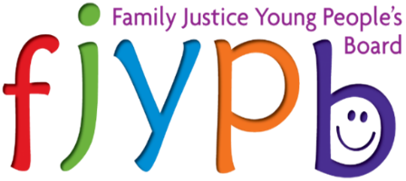
Please return your completed VOTC Webinar application form to fjypb@cafcass.gov.uk

