Too much sugar is bad for children's health as it can lead to the build-up of harmful fat inside our bodies, which we can't see. This fat can cause weight gain, serious diseases and also leads to tooth decay.

For more information and some great tools to help you and your family have a better understanding of how much sugar children are having and changes you can make, check out: Reducing Sugar | Cutting Out Sugar | Change4Life (www.nhs.uk)

Below you will find some common Easter treats and how many teaspoons of sugar they contain:

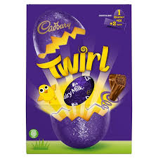 | 56g per 100g  237g total  56 / 4 = 14  14 x 2.37 = 33.18 tsp  Rounded down to 33 cubes
53.6 per 100g
75g

53.5 / 4 = 13.4
13.4 x 0.75 = 10.05 tsp

Rounded down to 10 Cubes
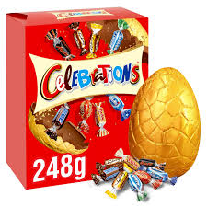 | 59g per 100g  248  59 / 4 = 14.75  14.75 x 2.48 = 36.58 tsp  Rounded up to 37 cubes
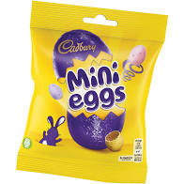 | 69g per 100g  80g  69 / 4 = 17.25  17.25 x 0.80 = 13.8 tsp  14 Cubes

Healthy Lifestyles Easter Treats - Sugar Fact Sheet
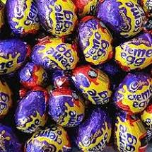 | 66.5g per 100g  40g per egg  66.5 / 4 = 16.6  16.6 x 0.40 = 6.6 tsp  7 cubes
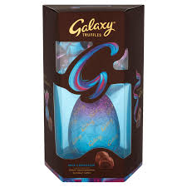 | 52g per 100g  301g  52 / 4 = 13  13 x 3.01 = 39.13 tsp  39 cubes
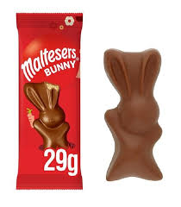 | 53g per 100g  29g  53 / 4 = 13.25  13.25 x 0.29 = 3.8 tsp  4 cubes

To work out the number of teaspoons of sugar in an item use the following:

- 1 teaspoon of sugar equals 4g of sugar.
- For example; an item containing 20g of sugar would have 5 teaspoons of sugar in it.
- Remember to work out the amount of sugar in the item, not just the amount per 100g. If the item you are using is 300g then you will need to multiply by 3.

For example;

- A 300g bag of sweets has 50.4g of sugar per 100g.
- 50.4 divided by 4 equals 12.6
- That’s 12.6 teaspoons of sugar per 100g of the sweets
- As there are 300g of sweets in the bag multiply 12.6 by 3 and this tells you there are 38 teaspoons of sugar in the bag of sweets.

