Healthy Lifestyles Sugar in Cereal Fact Sheet
What is a portion?
A portion of cereal usually varies from 30g – 45g depending on the brand and type of cereal. To put this into context, a variety pack box of coco pops is 30g.
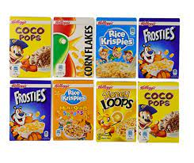
Many of us have a lot more than the recommended portion size, often having double or even triple this amount. The sugar content of the cereals in this fact sheet have been worked out per 100g as this is the easiest way to compare each cereal. Each packet will also tell you how much sugar is in them per portion or serving.

For the purpose of this fact sheet we are using sugar cubes as the equivalent, however 1 cube also equals 1 teaspoon.

Recommended daily cube amounts for children –
- 4-6 year olds – 5 cubes
- 7-10 year olds – 6 cubes
- 11+ years - 7 cubes
Cornflakes sugar content per 100g  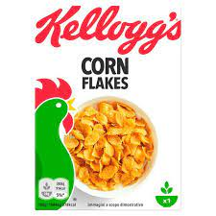 | 8g of sugar = 2 cubes
Special K sugar content per 100g  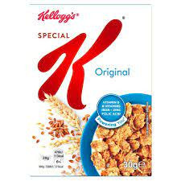 | 15g of sugar = 3.75 cubes

Coco Pops sugar content per 100g  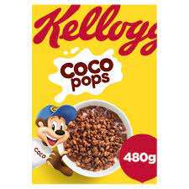 | 17g of sugar = 4.25 cubes
Krave Milk Chocolate sugar content per 100g  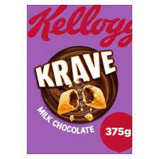 | 28g of sugar = 7 cubes
Krave Chocolate Hazelnut sugar content per 100g  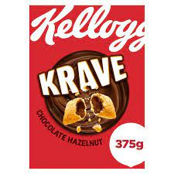 | 29g of sugar = 7.25 cubes
Weetabix sugar content per 100g  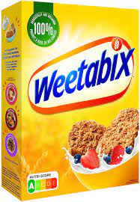 | 4.2g of sugar = 1.5 cubes
Weetabix Chocolate Crispy Minis sugar content per 100g  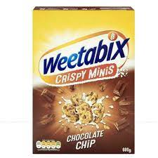 | 17g of sugar = 4.25 cubes
Shreddies Original sugar content per 100g  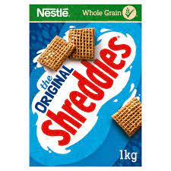 | 13g of sugar = 3.25 cubes
Shreddies Chocolate sugar content per 100g  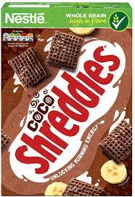 | 27g of sugar = 6.75 cubes
Shredded Wheat sugar content per 100g  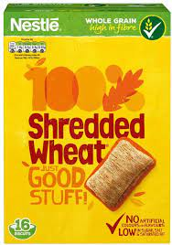 | 0.7g of sugar = 0.1 cubes
Nesquik Chocolate and Banana Pillows sugar content per 100g  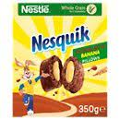 | 24.6g of sugar = 6.1 cubes
Ready brek Smooth porridge sugar content per 100g  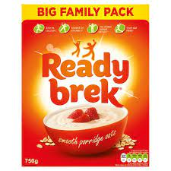 | 1.0g of sugar = 0.25 cubes
Oreo O’s Cereal sugar content per 100g  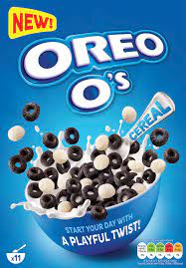 | 27g of sugar = 6.75 cubes
Rainbow Hoops sugar content per 100g  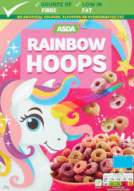 | 21g of sugar = 5.25 cubes
Frosties sugar content per 100g  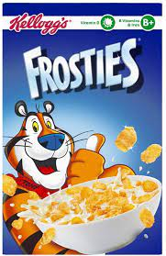 | 37g of sugar = 9.25 cubes
Cookie Crisp sugar content per 100g  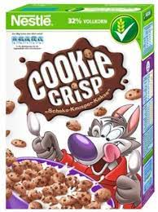 | 22g of sugar = 5.5 cubes
Oat So Simple Golden Syrup Porridge sugar content per 100g  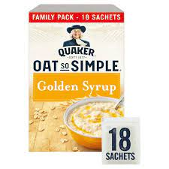 | 19g of sugar = 4.75 cubes
Oat So simple Original Porridge sugar content per 100g  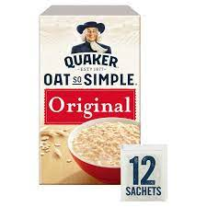 | 1.0g of sugar = 0.25 cubes
Rice Krispies sugar content per 100g  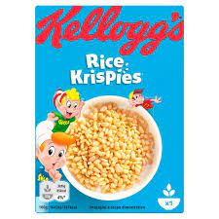 | 7.9g of sugar = 1.9 cubes
Crunchy Nut sugar content per 100g  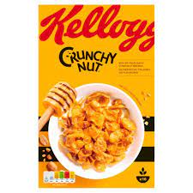 | 35g of sugar = 8.75 cubes
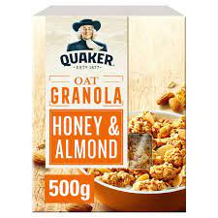  Simply Granola sugar content per 100g | 19g of sugar = 4.75 cubes

Have you been surprised by these amounts? Has it encouraged you to make any cereal swaps?
If the cereal your family eats isn’t listed why not check the label and work out the sugar content. You’ll find this information on the back of the box in the nutritional information panel, listed under ‘carbohydrate, of which is sugars’. Whatever the amount listed is, then divide it by 4 to get the amount in teaspoons.

Additional Info
You can also download the Change4Life Smart Scanner free app. This allows you to scan the barcodes on products and it will automatically tell you how much sugar, fat and salt is in the product without you having to work anything out! Why not try this as a family with other items in your cupboards. This is also useful food label information - Food Labels | Nutrition Labels | Change4Life (www.nhs.uk)

