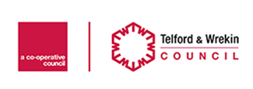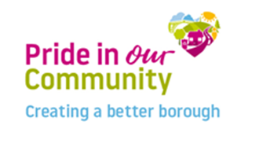Balfour Beatty Highways Hub

To Residents,

Granville House

St Georges Road

Donnington Wood

Telford

TF27RA

Highway improvements in your area

Various Carriageway & Footway Works

Dear Resident,

As part of the Council’s ongoing investment into its roads and footpaths, we will shortly be carrying out Various Works on Bennetts Bank, Wellington. Works include: Carriageway Resurfacing/Re-alignment, New Parking Bays, Footway Works, Drainage Works, New Bus Stop, & Road Markings.

When are we planning to deliver this work?

The work is due to take place on 14th March and be completed by 06th May (weekdays only), weather permitting. The works will be carried out under a Phased Traffic Management:

* Phase 1 – 14/03-08/04 – 24hr Lane Closure - Westbound from Ketley Brook Rbt to Cock Hotel Traffic Signals
* Phase 2 – 11/04-29/04 – 24hr Lane Closure - Westbound from Ketley Brook Rbt to Cock Hotel Traffic Signals
* Phase 3 – 02/05-06/05 – Road Closure (In place between 18:30-06:00)

We will be working between 08:00-17:00 (Weekdays Only).

We will have our dedicated teams on site to assist you during this time to help you get past the working areas safely should you need to do. Whilst we will endeavour to minimise disruption, we ask that you keep vehicle movements to an absolute minimum and not to park on the road. Please also ensure that children are supervised, do not play near the working areas and all pets are kept away from the works.

Information about access to your property

Access will be maintained during the works for residents and for emergency vehicles although there will be short periods of time when the contractors will require residential and commercial traffic to be excluded during planing of the road surface and to allow the surfacing material to harden. We will try to cause as little inconvenience as possible and really appreciate your co-operation whilst we are undertaking the works.

**If you have any special access requirements while the works are in progress or need to contact Balfour Beatty about these improvements please contact us at our new Telford Highways Hub:** [TelfordHighwaysHub@Balfourbeatty.com](mailto:TelfordHighwaysHub@Balfourbeatty.com) **and a member of our team will be in contact with you shortly.**

Thank you for your co-operation whilst we deliver these improvements in your area.

**These works are part of the Council’s 4 year investment programme to Protect, Care and Invest to create a better borough, between 2020 and 2024 we are investing over £50m to keep neighbourhoods safe, clean and well connected. The ‘Pride in Our Community’ programme will deliver improvements to infrastructure including roads, footpaths, parking, sustainable transport, street furniture, drains and structures.**

**Our highways vision is to ‘Keep Telford Moving’ and in 2021/2022 we will invest £21.6m to deliver over 160 improvement schemes across the borough.**

More Information about roadworks in Telford can be found at [www.telford.gov.uk/roadworks](http://www.telford.gov.uk/roadworks)

For more about the Council’s Pride in Our Community programme visit [www.telford.gov.uk/pride](http://www.telford.gov.uk/pride).

**Balfour Beatty Telford Highways Hub- *Working on behalf of Telford & Wrekin Council***

**cid:image006.jpg@01D4BFA4.7F80B470**