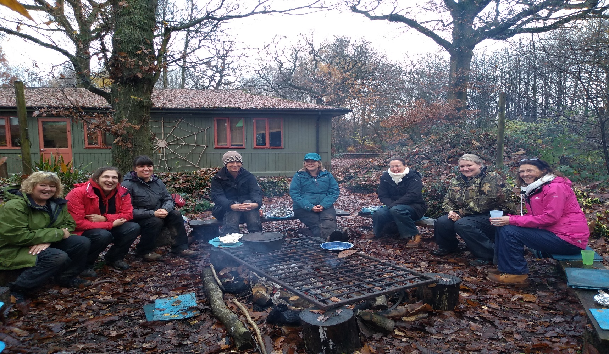

Forest School Level 3
Training

Join us in Spring 2024
Run by an experienced team of Forest School trainers.
Dates of training 2024
9th 10th 16th 17th 23rd 24th 30th April
1st & 2nd May

Location; Preston Montford Field Centre, Shrewsbury SY4 1DX
For more information and to ask any questions about this course call Vicki or Rachel on 01299 250253 or visit our website.
You will spend 9 days with our training team learning first hand all about Forest Schools. You will discover what Forest Schools is, how to set up a site, what tools and equipment you will need. You will practice and learn new skills such as shelter building, fire lighting, how to use tools, how to make natural crafts and cook food on an open fire. | Throughout the training you will gain confidence in working outside, learn about woodland ecology and how to identify plants and animals. You will delve into how we connect children and adults with nature, raise their self-esteem and confidence and practical skills. This course is delivered mainly outdoors.

