Forest School Training Level 3 Qualification
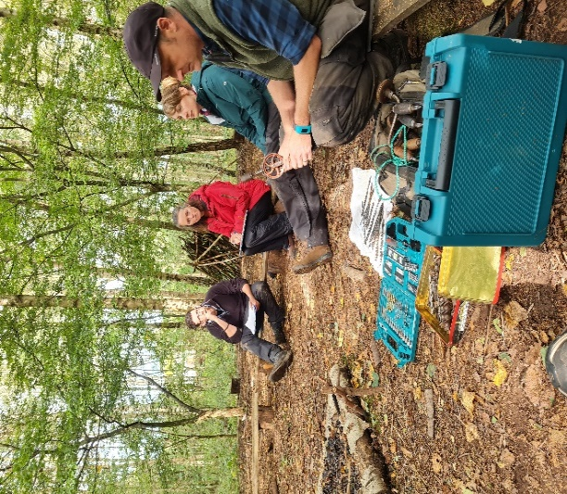
The Bishops Wood training team has been delivering high quality Forest School Training for over 15 years. Accredited through Aim Qualifications and Assessment Group we offer level 1, 2 and 3 qualifications.
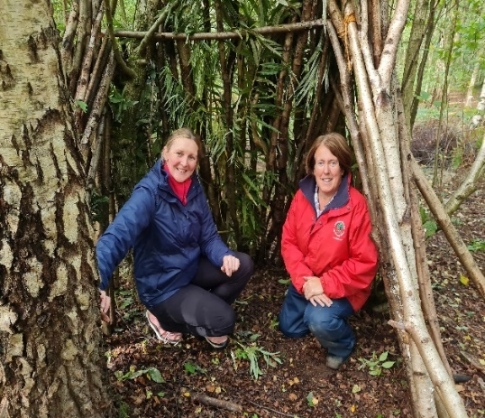
We have an experienced training team who have delivered Forest School sessions and training across the West Midlands. We have a wealth of experience in Early Years Work, Primary school teaching, habitat management and working with children with challenging behaviour. Our trainers have delivered forest school sessions to early years groups right the way through to teenagers and beyond. We have been employed by schools and worked freelance across a range of settings. We have set up many forest school sites from scratch. All of this will give you a wealth of knowledge to help you on your Forest School Journey, what ever your situation and background.
You will spend 9 days in our beautiful woodland at Bishops Wood or Preston Montford. You will be given on going support whilst you complete your assignments and beyond. We will come and visit you in your setting to offer guidance and to see how your work has developed.
All tools and equipment are provided throughout. Just bring your enthusiasm for the outdoors.
You will produce a portfolio of work that will be submitted in stages online. If you need support to submit work we have people on hand to help you with this.
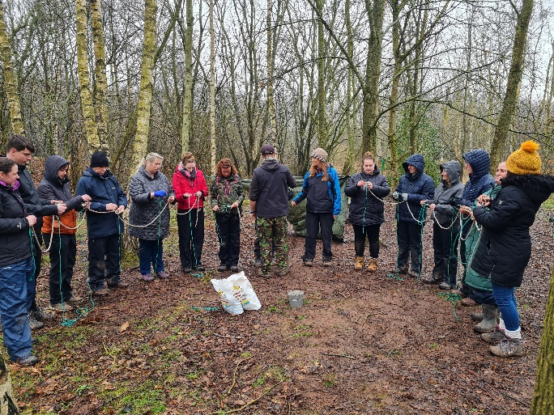
Why train with us? Our training team has a wealth of knowledge, and we have all delivered Forest Schools in a range of settings ourselves. We know firsthand the challenges faced as a teacher, freelancer and employee of a school. Our training is very practical and hands on. You will learn by experience and doing. You will have chance to practice your skills in a safe and supportive environment which means when you have completed the course you will be ready and confident to lead your own forest school session. You will spend time working with others on the course building up your network of like-minded people. The training team are always on hand to answer questions and support you with your portfolio and whatever you may need help with. We offer ongoing support even when you have your qualification.

Title of course | Level 3 Certificate For Forest School Leaders
Awarding body | Aim Qualification and Assessment Group
Qualification Number | 603/2406/5
Credit value | 18 Credits
Guided learning hours | 96 hours.  For this learners will be required to attend 9 days of training at Bishops Wood or Preston Montford sites.  Learners will also need to lead a minimum of 6 Forest School Sessions.
Total qualification Time | 180 Hours
Minimum Age | 19* Please note the minimum age for qualified Forest School Leaders is 21 (This is a Department for Education Requirement).
Qualification Aim | Aim Qualification and Assessment Group Level 3 certificate for Forest School Leaders provides learners with the knowledge and skills required to support individuals in Forest School programmes and outdoor learning. This qualification enables learners to gain the skills and knowledge required to plan and lead Forest School programmes.
Progression routes | 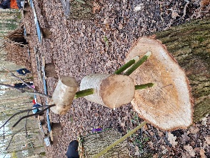  This qualification is designed to develop leadership, facilitation, practical and teaching skills to enable learners to understand the principles and ethos of Forest School. It also enables learners to deliver Forest School programmes. It is designed to meet the needs of school and college staff, teachers and teaching assistants, youth workers, adults and professionals in training to become a Forest School leader. This qualification will prepare learners for further study and employment in the outdoors.
Rules of combination | Learners must complete a total of 18 credits to achieve this qualification.
First Aid Qualification | You will also need to hold a First aid qualification that includes outdoor elements of 16 hours or more, suitable for your client group to gain this qualification.
Units covered | The qualification in more detail  The qualification is made up of 5 units.  The Woodland Environment Unit  Looks at the ecology and ecosystems of your site and woodlands, how to identify species there and why this is important and how to look after your site sustainably.  Practical Skills Unit  How to light fires safely with your group including safe siting, safe management and risk assessments. How to use a range of tools safely yourself and with the children you work with. How to make simple items from wood using tools. How to tie knots and use them at Forest School. How to build shelters and ensure this is done safely. How to cook on an open fire, considering food and hygiene.  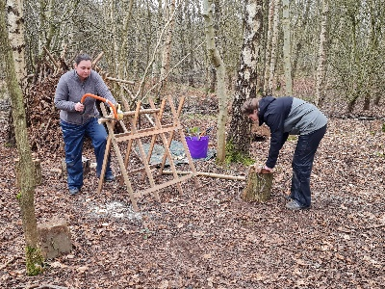  Learning and Development Unit  Looks at the theories behind the practice, includes play, learning theories, holistic development, the importance of self-esteem, emotional intelligence and resilience. This unit also looks at reflective practice and what we have discovered and learnt delivering our forest school sessions.  Planning and Preparation Unit  This unit prepares you for delivering your own forest school, whether it is an existing forest school, or you are starting from scratch. We will look at all the policies and procedures and risk assessments as well as your site. To ensure you are ready to start sessions safely.  Delivery Unit  This is the ‘doing’ part. You will deliver your forest school sessions, observe and reflect on how it has gone and what impact your sessions have had.
Assessment method | Portfolio of evidence and practical assessments during the training.
Included in the course | Handouts and a folder which will help you complete your portfolio.  Online resources are also available and will help you to complete your assignments.
What you will need to bring to the training. | A lot of the course is run outdoors so please bring appropriate clothing for the time of year. Steel toe capped boots or very strong footwear such as walking boots will be required.  Camera  Notebook  Pens and pencils  Lunch
Timings | Usually 9am – 5pm each day
Lunches and refreshments | Hot drinks are available through the day. Please bring a lunch with you.  On the last day of training, we cook a 3-course meal over a camp fire.
Dates of courses running in 2024  (Learners will need to attend all 9 days from one cohort) | April 2024 course – Preston Montford site  9th 10th 16th 17th 23rd 24th 30th April  1st & 2nd May  July 2024 course – Preston Montford site  30th July – 8th August – Residential/full board option available.  Oct 2024- Bishops Wood Site  8th & 9th October  15th & 16th October  12th & 13th November  19/20th/21st November  For any questions or to discuss further please contact  Lead Trainer Vicki Wood v.wood@field-studies-council.org Tel: 01299 250513
