Viewing Secondary Allocations for Year 6 Pupils

Log into SAM Portal, select ‘Secondary 2023’ round and ‘Round Summary’.
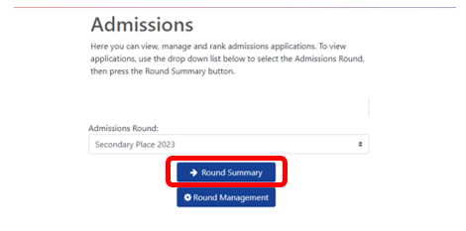

Navigate to ‘View Leavers’ from the ‘Reports’ section on the bottom right of the page.
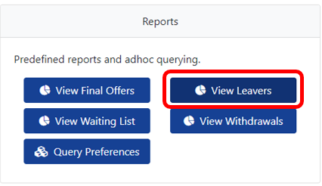

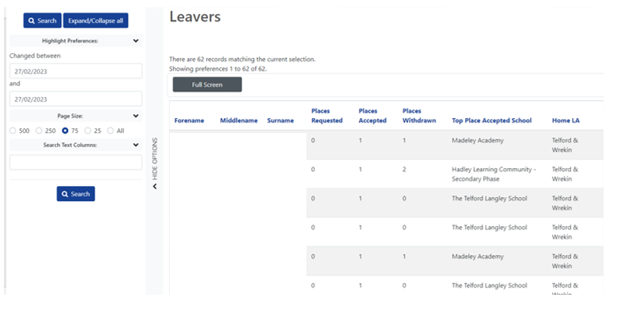
This will present you with a list of Year 6 pupils and where they have been offered a space for Secondary 2023. Each pupil will be listed individually here alongside their allocated school.

The offer list can then be exported to an Excel by selecting ‘Actions’ and ‘Export to excel’. Your list will then download as an Excel document.
