NPQEYL Delivery in Shropshire and Telford

STEP (Shropshire and Telford Education Partnership) in partnership with the Alliance of Leading Learning brings to Early Years Providers and Childminders the new NPQEYL.
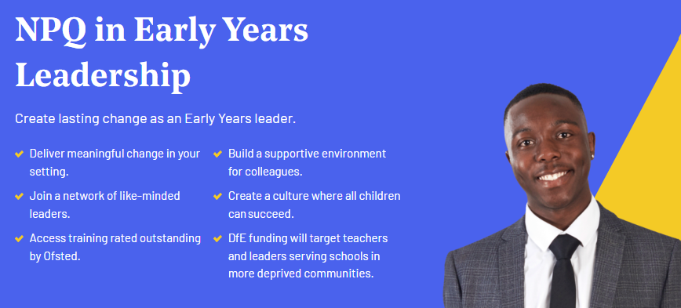
The NPQEYL is a DfE accredited programme that we deliver with Teach First.
Funding worth £1090 is available to cover the cost of this 18 month programme.
For the October 2024 cohort, scholarship funding for some NPQs is limited to those working in eligible high-disadvantage settings. All Ofsted-Registered Childminders and those registered with an Ofsted-Registered Childminder Agency, will be eligible for scholarship funding if they are accepted onto a place for NPQEYL. Secure a funded place by applying early.
Who is it for?
NPQEYL is for leaders qualified to at least level 3 with a full and relevant qualification* who are, or are aspiring to be**:
- managers of private, voluntary and independent nurseries
- headteachers of school-based or maintained nurseries
- childminders with leadership responsibilities (you work with, employ or are close to employing an assistant)
What will I learn?
You’ll develop expertise in the knowledge, skills and concepts for leading an Early Years setting. These include best practice around child development and additional and special educational needs, as well as culture, organisational management and partnerships you may make as the leader of an Early Years setting.
Content will include core elements of the framework:
• Culture
• Child development, curriculum and assessment
• Additional and special educational needs
• Professional development
• Organisational management
• Working in partnership
• Implementation
How will I benefit?
* Develop as a leader with responsibility across an Early Years organisation and learn how to create an effective culture in your setting.
* Access content across a breadth of areas such as culture, child development, curriculum and assessment, and organisational management.
* Be supported to effectively implement change and improvement in an area you identify as a setting priority.
How to Apply?
https://leadinglearning.co.uk/npqeyl-and-npqll-applicants/


