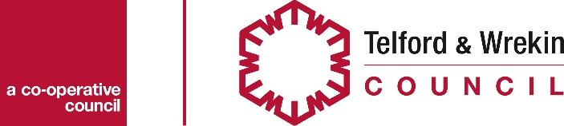

Expression of Interest Requirements – Holiday Activities and Eatwell Fund

Please read the guidance document before submitting your Expression of Interest. Your Expression of Interest should include the following information;
Organisation
Name and type of organisation, where you are based and contact details (including telephone number and email address) of person submitting expression of interest
Project Summary
Please give a brief overview of your project ensuring that you include the following;
- The type of activities you will be delivering and how you will incorporate a healthy meal or snack
- When the project will be delivered, how many sessions, length of sessions (you need to cover multiple holidays for the period Summer 2019 to Easter 2020 inclusive)
- Who will deliver the project
- Who else will support you to deliver the project e.g. volunteers, partner organisations, local businesses
- How does your project link in with any other projects in your area
Project Beneficiaries
Please provide the estimated number of beneficiaries (per session/per holiday), the age group that you are targeting and whether or not this includes their families.
Please provide details of how you intend to reach your target recipients (children and young people in receipt of free school meals and families on low incomes)
Project Costs
Please give a breakdown of the total estimated costs of your project, how much funding you will require from this fund and any other sources of funding that you have secured.
Please provide a schedule (key dates) when you would require your grant payments.
Sustainability
Please provide details of how you intend to sustain the continuation of the project once this funding ceases
Track Record of Project Delivery
Please provide details of who will lead on the delivery of the project and what experience they have of delivering similar projects in the past. Please confirm what policies and procedures that you have in place to ensure the safe and effective delivery of your project.
Partner Support
Please provide details of any support you require from the Council or other partners to enable you to deliver your project.

