ANTI-SOCIAL BEHAVIOUR, CRIME AND POLICING ACT 2014, (SECTION 59)

BOROUGH OF TELFORD & WREKIN DOG CONTROL PUBLIC SPACES PROTECTION ORDER 2025

STATEMENT OF REASONS

The Borough of Telford & Wrekin Dog Control Public Spaces Protection Order 2025
is proposed across the Borough to prevent, manage and tackle recurring dog fouling issues and inadequate control by some dog walkers. Once established the proposed Public Space Protection Order (PSPO) will enable authorised Council Officers, constables and Police Community Support Offices to request a number of actions to be undertaken by the dog walker / owner and to take enforcement action where necessary through use of the power to issue Fixed Penalty Notices.

In order to ensure a consistent standard throughout, it is intended that the PSPO would apply to all public spaces within the Borough.

Across the Borough since the PSPO was granted in July 2022 there has been an increase in dog foul offences.

2022 – 454
2023 – 1528
2024 – 2246

This demonstrates that the problem has not been resolved, and the issue persists. However, this does also demonstrate that residents are actively reporting dog fouling and that dog walker engagement, online education and PSPO enforcement opportunities are working.

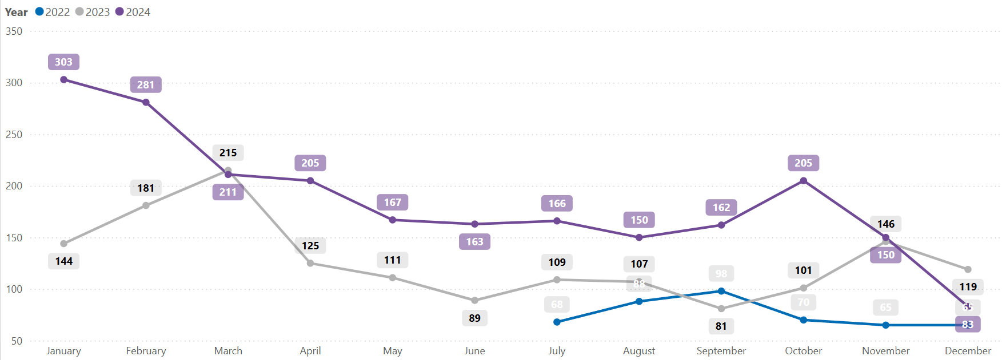

Dog fouling is unpleasant for all those seeking to enjoy our public open spaces. It also poses health risks, with direct contact potentially leading to toxocariasis (a dangerous infection affecting humans that can cause dizziness, nausea, asthma and even blindness or seizures).

Whilst the occurrence of such infection is generally low, there is still a need to consider how we best mitigate such risk and this proposed PSPO would ensure that dog walkers take full responsibility for removing dog waste and ensure that their dogs are prevented from fouling close to children’s play areas and public open spaces linked to sporting activities (where the risk of exposure to toxocariasis is greater).

A PSPO allows for greater responsibility to be placed upon dog walkers when in public spaces, ensuring green public open spaces are both free of dog waste and safe for all to enjoy.

