





School Admission Policy
2027 – 2028

“I have come that they may have life, and have it to the full” (John 10:10 )

Policy Type | Policy Number | Prepared By (Job Title) and Date
Statutory | S02 | Admissions Committee  Autumn 2022
Approval Date | Review Frequency | Review Due Date
22.11.22 | Annually  (Statutory Frequency) | Autumn 2026
Signed on behalf of the Governing Body G M Kendrick (Chair)


St Patrick’s Catholic Primary school and Shrewsbury Cathedral Catholic Primary school were founded by the Catholic Church to provide education for children of Catholic families. Whenever there are more applications than places available, priority will be given to Catholic children in accordance with the oversubscription criteria listed below. The school is conducted by its academy company as part of the Catholic Church in accordance with its trust deed and articles of association and always seeks to be a witness to Our Lord Jesus Christ.
As a Catholic school we aim to provide a Catholic education for all our pupils. As a Catholic school, Catholic doctrine and practice permeate every aspect of the school’s activity. It is essential that the Catholic character of the school’s education be fully supported by all families in the school. We therefore hope that all parents will give their full, unreserved and positive support for the aims and ethos of the school. This does not affect the right of an applicant who is not Catholic to apply for and be admitted to a place at the school in accordance with the admission arrangements.

The Academy Company our Lady Help of Christians Catholic Academy Trust is the admissions authority and has delegated responsibility for admissions to the Local Governing Body
The Local Authorities for their respective school Telford & Wrekin Council for St Patrick’s and Shropshire Council for Shrewsbury Cathedral, undertake the co-ordination of admission arrangements during the normal admission round (this is for admissions to the school at the start of the school year and not for applications made in year). The admissions authority has set its published PAN for both schools at 30 pupils to be admitted to the reception year in the school year which begins September 2027
The Academy Company will, where logistically possible, admit twins and all siblings from multiple births where one of the children is the last child ranked within the school’s PAN.

Pupils with an Education, Health and Care plan (see note 1)
The admission of pupils with an Education, Health and Care Plan (EHCP), is dealt with by a separate procedure. Children with an Education, Health and Care Plan that names the school must be admitted. Where this takes place before the allocation of places under these arrangements this will reduce the places available to other children.

Oversubscription Criteria

Where there are more applications for places than the number of places available, places will be offered according to the following order of priority.

Oversubscription Criteria for St Patrick’s Catholic Primary School
- Catholic looked after and previously looked after children. (See note 2 and 3)
- Catholic children who are resident in the parish of St Patrick’s, Wellington, Telford, Shropshire. (See notes 6 and 7)
- Other Catholic children (See note 3)
- Other looked after and previously looked after children (see note 2)
- Any other children

Oversubscription Criteria for Shrewsbury Cathedral Catholic Primary School
- Catholic Looked after and previously looked after children. (See note 2 and 3)
- Catholic children who are resident in the Cathedral Parish Shrewsbury including the Cathedral church of Our Lady Help of Christians and St Peter of Alcantara, and St Winefride’s, Monkmoor.
- Other Catholic children (See note 3)
- Other looked after and previously looked after children (see note 2)
- Any other children

Within each of the categories listed above, the following provisions will be applied in the following order:
- The attendance of a ‘brother or sister’ at the school at the time of enrolment will increase the priority of an application within each category so that the application will be placed at the top of the category in which the application is made after children in (1) above (see note 4).

Tie Break
Priority will be given to children living closest to the school determined by the shortest distance. Distances are calculated on the basis of the straight-line distance between a central point in the school building and a central point in the child’s home. The distances will be measured using the Local Authorities Geographical Information Systems. In the event of distances being the same for two or more children where this would determine the last place to be allocated, random allocation will be carried out and supervised by a person independent of the school. All the names will be entered into a hat and the required number of names will be drawn out.

Application Procedures and Timetable

To apply for a place at St Patrick’s in the normal admission round, you must complete an online application via the Local Authority’s Website:
Telford & Wrekin Council | Starting School.
You must also complete the Supplementary Information Form (SIF) attached to this policy. The SIF and proof of baptism should be returned to St Patrick’s school office by 15th January 2027

To apply for a place at Shrewsbury Cathedral in the normal admission round, you must complete an online application via the Local Authority’s Website:

http://www.shropshire.gov.uk/school-admissions/starting-or-transferring-school/starting-infant-or-primary-school/
You must also complete the Supplementary Information Form (SIF) attached to this policy. The SIF and proof of baptism should be returned to Shrewsbury Cathedral’s school office by 15th January 2027

If you do not provide the information required in the SIF and return it by the closing date, together with all supporting documentation to the respective school, your child may not be placed in criteria 1 to 4 and this may affect your child’s chance of being offered a place.

You will be advised of the outcome of your application on 16th April or the next working day, by the local authority on our behalf. If you are unsuccessful (unless your child gained a place at a school ranked higher) you will be informed of the reasons, related to the oversubscription criteria listed above, and you have the right of appeal to an independent appeal panel.

Late Applications
All applications which are submitted on time will be considered at the same time and after the closing date for admissions which is 15th January 2027. Applications received after this date will be treated as late applications and will not be considered until after the main allocation of places has taken place.

Admission of Children Below Compulsory Age and Deferred Entry

A child is entitled to a full-time place in the September following their fourth birthday. A child’s parents may defer the date at which their child, below compulsory school age, is admitted to the school, until
Later in the school year but not beyond the point at which they reach compulsory school age, or beyond the beginning of the final term of the school year for which an offer was made. A child may take up a part-time place until later in the school year, but not beyond the point at which the child reaches compulsory school age. Upon receipt of the offer of a place a parent should notify the school as soon as possible that they wish to either defer their child’s entry to the school or take up a part-time place.
.

Admission of children outside their Normal Age Group

A request may be made for a child to be admitted outside their normal age group, for example, if the child is gifted and talented or has experienced problems such as ill health. in addition, the parents of a summer born child, i.e. a child born between 1st April and 31st August, may request that the child be admitted out of their normal age group, to reception rather than year 1.
Any such request should be made in writing to the Executive Headteacher at the same time as the admission application is made. The admissions authority will make its decision about the request based on the circumstances of each case and in the best interests of the child. In addition to taking into account the views of the Executive Headteacher, including the Executive Headteacher’s statutory responsibility for the internal organization, management and control of the school, the admission authority will take into account the views of parents and of appropriate medical and education professionals, as appropriate.
If a formal request to delay entry for summer born children is agreed, Parents would need to reapply for a reception place in the following year and that a place would be subject to the oversubscription criteria in the normal manner

Waiting Lists
In addition to their right of appeal, unsuccessful children will be offered the opportunity to be placed on a waiting list. This waiting list will be maintained in order of the oversubscription criteria set out above and not in the order in which applications are received or added to the list. Waiting lists for admission will operate throughout the school year. The waiting list will be held open until the last day of the summer term 2028
Inclusion in the school’s waiting list does not mean that a place will eventually become available.

In Year Applications St Patrick’s Catholic Primary School
An application can be made for a place for a child at any time outside the admission round and the child will be admitted where there are available places. Enquiries may be made at the school office by phoning 01952 386160,or emailadmin.stpatricks@blessedec.co.uk an application must also be made by contacting Admissions at Telford and Wrekin by email: admissions@telford.gov.uk
Where there are places available but more applications than places, the published oversubscription criteria, as set out above, will be applied. If there are no places available, the child will be added to the waiting list. You will be advised of the outcome of your application in writing, and you have the right of appeal to an independent appeal panel.
If your child wishes to enter the Reception Class anytime during school year, they must apply online at: T&W.gov.uk/school admission/apply to start/transfer school.
and also complete an Admissions form from the school

In Year Applications Shrewsbury Cathedral Catholic Primary School
An application can be made for a place for a child at any time outside the admission round and the child will be admitted where there are available places.
In addition to their right of appeal, if unsuccessful on allocation day, a child will automatically be added to the waiting list of their preferred school. Should a vacancy become available the highest ranked application held in accordance with the oversubscription criteria will be offered a place at the school by the co-ordinating Local Authority on behalf of the Trust.
Mid- term applications will be dealt with using the same admissions criteria given above. Applications must be made via the Shropshire Council online portal (Synergy-Homepage ) Shropshire.gov.uk. If There is a space in the relevant year group a place will be offered. A formal letter from Shropshire Council’s Admission Team on behalf of the school will be sent to the parent advising them of the offer and the need to contact school directly to arrange a start date.

If your child wishes to enter the Reception Class anytime during the school year, they must apply online at: Shropshire.gov.uk/school admission/apply to start/transfer school, and also complete an Admissions form from the school.

Fair Access Protocol

The school is committed to taking its fair share of children who are vulnerable or hard to place, as set out in locally agreed protocols. Accordingly, outside the normal admission round the Academy Company is empowered to give absolute priority to a child where admission is requested under any locally agreed protocol. The Admissions Authority has this power, even when admitting the child would mean exceeding the published admission number (subject to the infant class size exceptions).

Notes (these notes form part of the oversubscription criteria)

- An Education, Health and Care plan is a plan made by the local authority under section 37 of the Children and Families Act 2014, specifying the special educational provision required for a child.

- A ‘looked after child’ has the same meaning as in section 22(1) of the Children Act 1989, and means any child who is (a) in the care of a local authority or (b) being provided with accommodation by them in the exercise of their social services functions (e.g. children with foster parents) at the time of making application to the school.

A ‘previously looked after child’ is a child who was looked after, but ceased to be so because he or she was adopted or became subject to a child arrangements order or special guardianship order. Included in this definition are those children who appear (to the Academy Company) to have been in state care outside of England and who ceased to be in state care as a result of being adopted.

- Catholic’ means a member of a Church in full communion with the See of Rome. This includes the Eastern Catholic Churches. This will normally be evidenced by a certificate of baptism in a Catholic Church or a certificate of reception into the full communion of the Catholic Church. For the purposes of this policy, it includes a looked after child living with a family where at least one of the parents is Catholic.
For a child to be treated as Catholic, evidence of Catholic baptism or reception into the Church will be required. Those who have difficulty obtaining written evidence of baptism should contact their Parish Priest who, after consulting with the Diocese, will decide how the question of baptism is to be resolved and how written evidence is to be produced in accordance with the law of the Church.

- ‘brother or sister’ includes:
- all natural brothers or sisters, half brothers or sisters, adopted brothers or sisters, stepbrothers or sisters, foster brothers or sisters, whether or not they are living at the same address; and
- the child of a parent’s partner where that child lives for at least part of the week in the same family unit at the same home address as the child who is the subject of the application.

- A ‘parent’ means all natural parents, any person who is not a parent but has parental responsibility for a child, and any person who has care of a child.

- For the purposes of this policy, parish boundaries are as shown on the attached map and will be applied to the admission arrangements for 2027/2028

Map attached Appendix A

- A child’s “home address” refers to the address where the child usually lives with a parent or carer and will be the address provided in the Common Application Form (“CAF”). Where parents have shared responsibility for a child, and the child lives for part of the week with each parent, the home address will be the address given in the CAF, provided that the child resides at that address for any part of the school week.

ADMISSION TO ST PATRICK’S/SHREWSBURY CATHEDRAL CATHOLIC PRIMARY SCHOOL
Supplementary Information Form 2027-2028

First Name of Child: |  | Surname:
Address of child: |  | Name of any siblings currently attending the school you are applying to:
Date of Birth:

Date from which you wish your child to attend school: |  |  | Year group into which you wish your child to be admitted:
Your Name: |  |  | Relationship to Child:
Your Telephone Number(s):

Your email address:

Is your child a Baptised Catholic:  Yes / No |  |  |  | For Baptised Catholics:  Month and Year of Baptism:  Parish:  Parish Location (Town/City):
All Catholic applicants are required to produce a baptismal certificate or a letter from the parish priest from the parish where baptism took place to confirm they are baptised Catholic. This evidence must be provided at the time of the application to the school and before the application deadline.
Signed:

Name (Please Print): |  | Date:

School use only:
SIF Received Date…………………. Signed……………………
Checklist for Reception Class Applications:
- Deadline – 15th January 2027
- Supplementary Information Form and Baptismal Evidence submitted to School
- School Place Application made to Local Authority

Evidence of baptism received & copied Date…………………. Signed……………………
Evidence of DOB received & copied (if applicable) Date…………………. Signed……………………

APPENDIX A
SHREWSBURY CATHEDRAL CATHOLIC PRIMARY SCHOOL AND NURSERY PARISH BOUNDARY MAP.

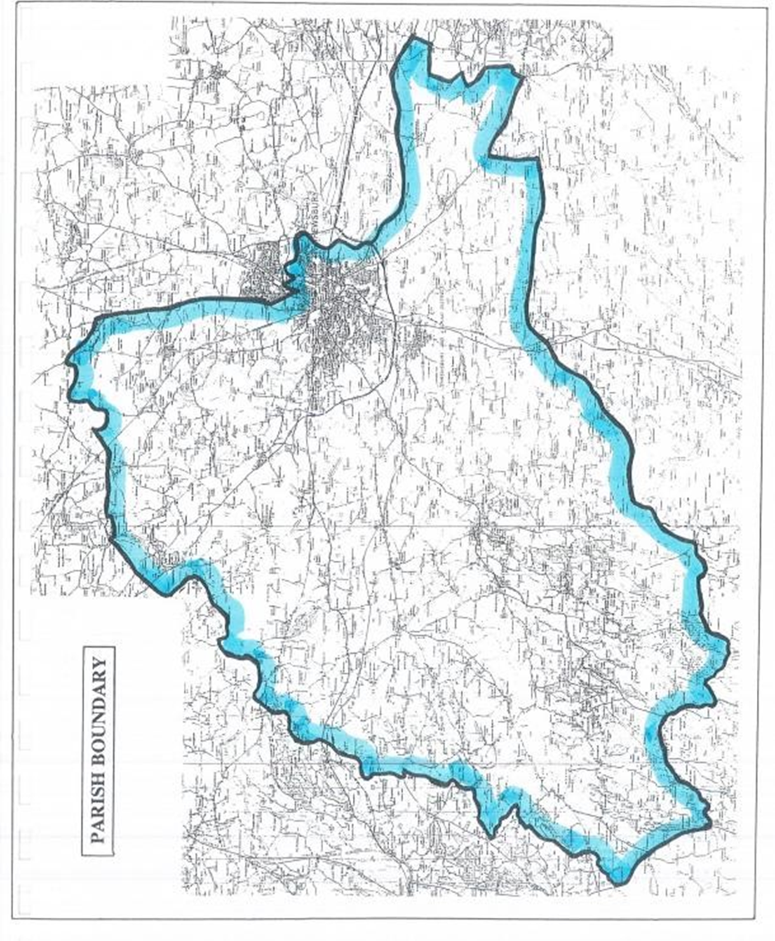

APPENDIX A
ST PATRICK’S CATHOLIC PRIMARY SCHOOL PARISH BOUNDARY

