
THE BOROUGH OF TELFORD AND WREKIN
HOUSING ACT 2004 SECTION 56
DESIGNATION OF AN AREA FOR ADDITIONAL LICENSING OF
HOUSES IN MULTIPLE OCCUPATION

THE BOROUGH OF TELFORD AND WREKIN (“the Council”) in exercise of its powers under Section 56 of the Housing Act 2004 (“The Act”) hereby designates for the Additional Licensing of Houses in Multiple Occupation (“HMOs”) the area described in Appendix A.
CITATION, COMMENCEMENT AND DURATION
- This designation may be cited as “The Borough Council of Telford and Wrekin Designation for an Area for Additional Licensing of Houses in Multiple Occupation 2026”.
- This designation was made on the 14 May 2026 by the Council and shall come into force on 25 August 2026.
- This designation will cease to have effect on 24 August 2031 or earlier if the Council revokes the scheme under Section 60 of the Act.
AREA TO WHICH THE DESIGNATION APPLIES
- This designation shall apply to all wards within the Borough of Telford and Wrekin as delineated and edged red on the map at Appendix A.
APPLICATION OF THE DESIGNATION
- This designation applies to all HMOs of the description specified in Appendix B within the area described in paragraph 4 unless:
a. The building is of a description specified in Appendix C (Buildings that are not HMOs for the purpose of the Act – other than Part 1);
b. The HMO is subject to an Interim or Final Management Order under Part 4 of the Act;
c. The HMO is subject to a Temporary Exemption Notice under Section 62 of the Act; or
d. The HMO is required to be licensed under Section 55 (2) (a) of the Act (Mandatory Licensing of HMOs).

EFFECT OF THE DESIGNATION
- Subject to sub paragraph 5(a) to (d) above, every HMO in the area specified in paragraph 4 that is occupied under a tenancy or a licence shall be required to be licensed under Section 61 of the Act.
The Borough of Telford and Wrekin Council will comply with the notification requirements contained within Section 59 of the Act and shall maintain a register of all houses registered under this designation, as required by Section 232 of the Act.
This designation falls within a description of designations in relation to which the Secretary of State has given general approval under Section 58 of the Act, namely the Housing Act 2004: Licensing of Houses in Multiple Occupation and Selective Licensing of Other Residential Accommodation (England) General Approval 2015 which came into force on the 1st April 2015.
CONSEQUENCES OF FAILING TO LICENCE AN HMO
- Failure to licence a property which requires licensing by virtue of this designation may result in an unlimited fine on summary conviction under the provisions of section 72 of the Act or a Civil Penalty of no more than £40,000.

A person who breaches a condition of the licence is liable upon conviction to a maximum fine of £5,000 or a Civil Penalty of no more than £40,000.

Tenants and/or the Council may apply for a rent repayment order under Sections 73 and 74 of the Act.

INSPECTION OF THE DESIGNATION

- The designation may be inspected at: Private Sector Housing Team, Southwater Square, Southwater One, Southwater Way, Telford TF3 4JG. Members of the public can be emailed copies of the designation upon request. Copies are also displayed on the Council’s website.

- The Private Sector Housing Team can be contacted via: Email: privatesectorhousing@telford.gov.uk

Website: https://www.telford.gov.uk/public-protection/licensing/houses-in-multiple-occupancy-hmos/

APPENDIX A – Map of Designated Area
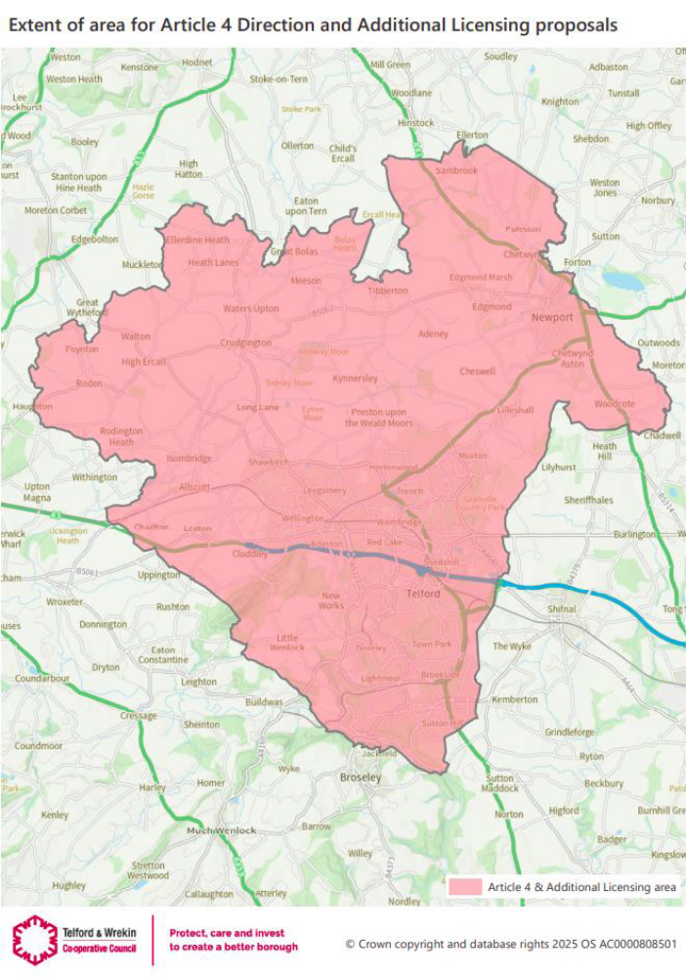

APPENDIX B – HMOs subject to the designation
The designation applies to all HMOs as defined by Section 254 of the Act that are occupied by three or more persons comprising two or more households, and HMOs as defined in Section 257 of the Act.
APPENDIX C – Buildings which are not HMOs for the purposes of this designation
The following paragraphs list buildings which are not houses in multiple occupation for any purposes of this Act other than those of Part 1.
In this Schedule “building” includes a part of a building.
Buildings controlled or managed by public sector bodies etc.
- A building where the person managing or having control of it is: -
- a local housing authority;
- a non-profit registered provider of social housing;
- a body which is registered as a social landlord under Part 1 of the Housing Act 1996;
- a police and crime commissioner;
- the Mayor's Office for Policing and Crime;
- a fire and rescue authority under the Fire and Rescue Services Act 2004; or
- a health service body within the meaning of section 9 of the National Health Service Act 2006.
- A building which is social housing within the meaning of Part 2 of the Housing and Regeneration Act 2008, and where the person managing or having control of it is a profit-making registered provider of social housing.

Buildings controlled or managed by a co-operative society

A building where: -

the person managing or having control of it is a co-operative society whose rules are such as to secure that each of the conditions set out in sub-paragraph (2) is met, and no person who occupies premises in the building does so by virtue of an assured tenancy, a secure tenancy or a protected tenancy.

The conditions are: -

a) that membership of the society is restricted to persons who are occupiers or prospective occupiers of buildings managed or controlled by the society;

b) that all management decisions of the society are made by the members (or a specified quorum of members) at a general meeting which all members are entitled to, and invited to, attend;

c) that each member has equal voting rights at such a meeting; and

d) that, if a person occupies premises in the building and is not a member, that person is an occupier of the premises only as a result of sharing occupation of them with a member at the member's invitation.

“co-operative society” means a body that is registered as a co-operative society under the 2014 Act or is a pre-commencement society (within the meaning of that Act) that meets the condition in section 2(2)(a)(i) of that Act, and is neither: -

a) a non-profit registered provider of social housing; nor

b) registered as a social landlord under Part 1 of the Housing Act 1996.

In this paragraph: -

“the 2014 Act” means the Co-operative and Community Benefit Societies Act 2014;

“assured tenancy” has the same meaning as in Part 1 of the Housing Act 1988;

“protected tenancy” has the same meaning as in the Rent Act 1977; and

“secure tenancy” has the same meaning as in Part 4 of the Housing Act 1985.

Buildings regulated otherwise than under this Act.

Any building whose occupation is regulated otherwise than by or under this Act and which is of a description specified for the purposes of this paragraph in regulations made by the appropriate national authority.

Buildings occupied by students.

Any building: -

a) which is occupied solely or principally by persons who occupy it for the purpose of undertaking a full-time course of further or higher education at a specified educational establishment or at an educational establishment of a specified description; and

b) where the person managing or having control of it is the educational establishment in question or a specified person or a person of a specified description.
In sub paragraph a) “specified” means specified for the purposes of this paragraph in regulations made by the appropriate national authority.

Sub-paragraph (4) below applies in connection with any decision by the appropriate national authority as to whether to make, or revoke, any regulations specifying: -

a) a particular educational establishment; or
b) a particular description of educational establishments.

Sub Paragraph (4) The appropriate national authority may have regard to the extent to which, in its opinion: -

a) the management by or on behalf of the establishment in question of any building or buildings occupied for connected educational purposes is in conformity with any code of practice for the time being approved under section 233 which appears to the authority to be relevant; or

b) the management of such buildings by or on behalf of establishments of the description in question is in general in conformity with any such code of practice, as the case may be.

In sub-paragraph (4) above “occupied for connected educational purposes”, in relation to a building managed by or on behalf of an educational establishment, means occupied solely or principally by persons who occupy it for the purpose of undertaking a full-time course of further or higher education at the establishment.

Buildings occupied by religious communities.

Any building which is occupied principally for the purposes of a religious community whose principal occupation is prayer, contemplation, education or the relief of suffering. This paragraph does not apply in the case of a converted block of flats to which section 257 applies.

Buildings occupied by owners.

Any building which is occupied only by persons within the following paragraphs: -

a) one or more persons who have, whether in the whole or any part of it, either the freehold estate or a leasehold interest granted for a term of more than 21 years;

b) any member of the household of such a person or persons; and

c) no more than such number of other persons as is specified for the purposes of this paragraph in regulations made by the appropriate national authority.

This paragraph does not apply in the case of a converted block of flats to which section 257 applies, except for the purpose of determining the status of any flat in the block.

Buildings occupied by two persons.

Any building which is occupied only by two persons who form two households.

